**Forecasting Stock Prices of Meta Platforms Inc. Using Weekly Historical Data**

Apoorv Vaishampayan

12/11/2024

**1. Executive Summary**

Meta Platforms Inc.'s stock price has fluctuated significantly since its initial public offering (IPO) in May 2012. The stock's history has been punctuated by periods of fast expansion, recovery, and innovative market responses. This research examines the historical trends, seasonality, and important events that influenced Meta's stock price between May 2012 and March 2024. We aimed to identify temporary and permanent seasonality, major drivers, and forecast future stock values. ​​By modifying the data to assure stationarity, we created models that could forecast Meta's stock price trend. According to the report, important drivers include AI investments, renewable energy efforts, and free cash flow increases, while difficulties come from competition, economic pressures, and metaverse investments. Based on time series analysis, our predictive model provides insight into future stock patterns, allowing stakeholders to make informed decisions.

**2. Discovery and Data Preparation**

**2.1 Data Source:**

This dataset provides weekly stock price information for Meta Platforms Inc. (formerly Facebook). It contains key attributes such as:

Opening price: Price at the start of the week.

Closing price: Price at the end of the week.

High price: The highest price recorded during the week.

Low price: The lowest price recorded during the week.

Volume: Total number of shares traded during the week.

Datetime: The week-ending date.

The dataset for this analysis consists of 618 entries of Meta Platforms Inc.'s weekly stock prices from the third week of May 2012 to the second week of March 2024 which translates to more than 11 years of stock price data. Preliminary plots of stock prices revealed non-constant variance and an upward trend which suggests that there is a mean which implicates non-stationarity in the data and has to be transformed to attain stationarity.

**Figure 2.1 Plot without any transformations**

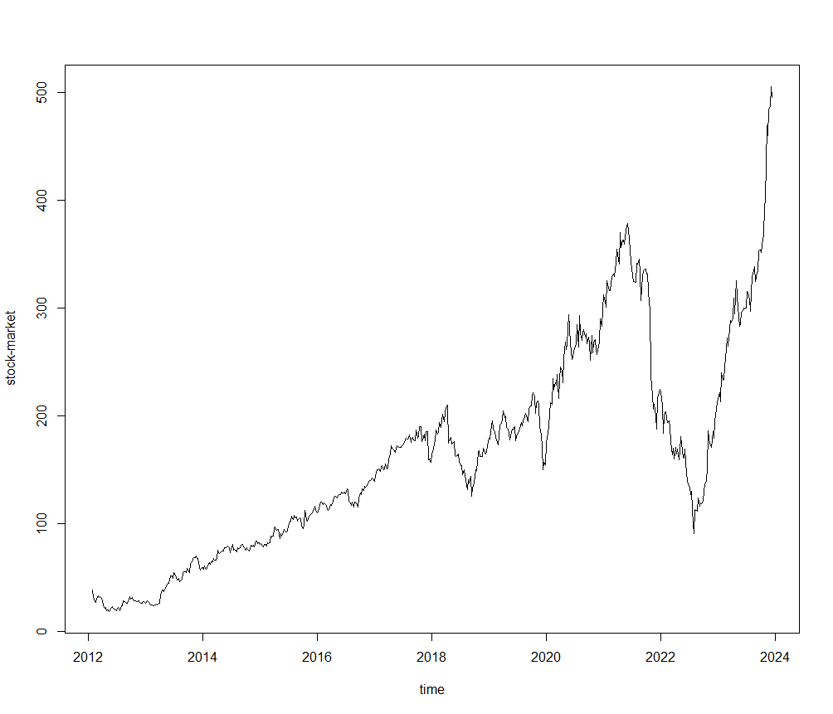

**2.2. Data Transformation**

The data was initially examined for stationarity with the Augmented Dickey-Fuller (ADF) test, which revealed a non-stationary series (p = 0.8012). To overcome this, we performed a logarithmic modification on the data which still revealed a non-stationary series with (p = 0.5109) . Then we performed differencing on the log-transformed data to make it stationary and obtained the stationarity as the ADF test also proves that after differencing the data yielded a p-value of 0.01, showing stationarity.

**Figure 2.2 Log-Transformed plot (left) and the Differencing on the log-transformed plot (right)**

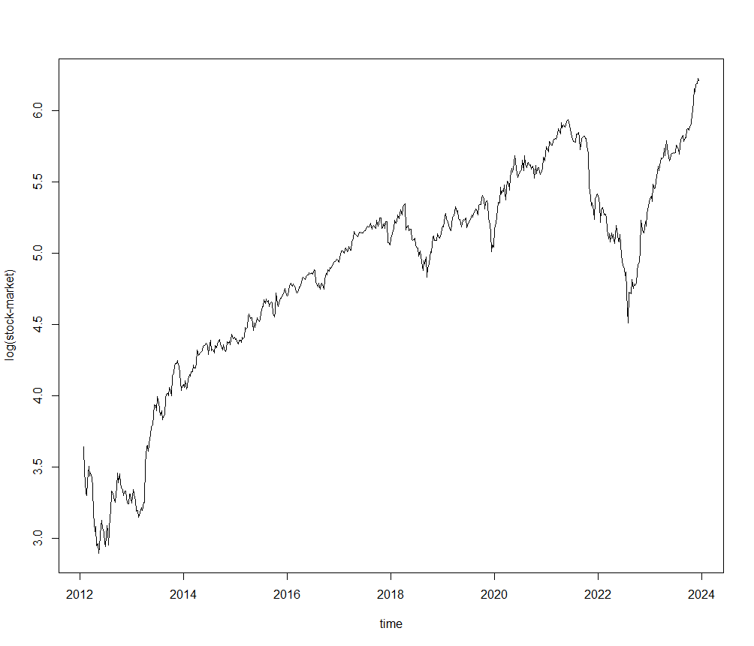 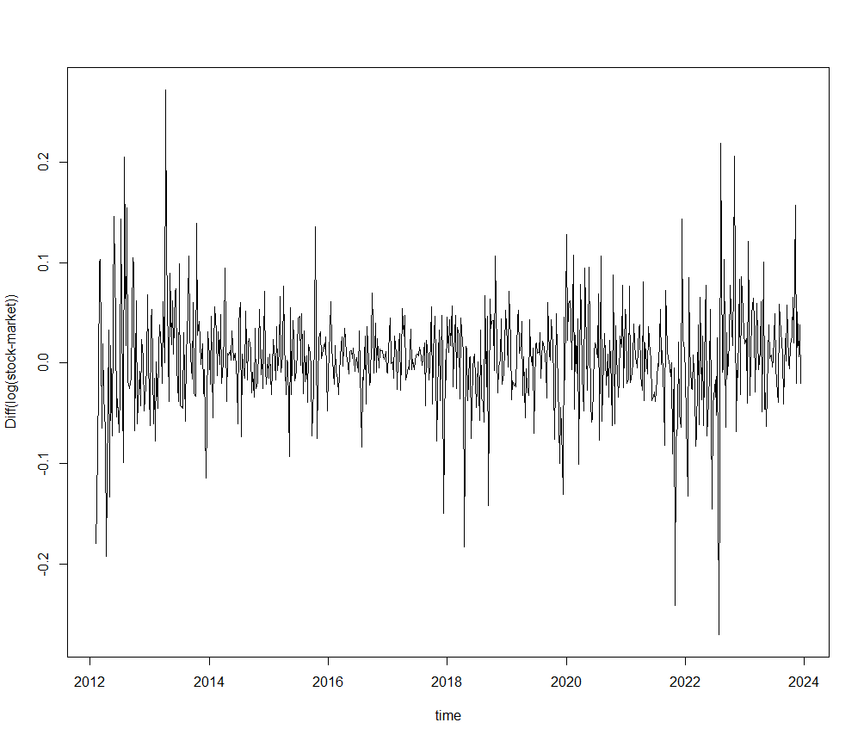

**3. Model Diagnostics**

Following the transformation, we performed diagnostic checks, such as plots of the autocorrelation function (ACF) and partial autocorrelation function (PACF), to find suitable lags for model selection along with extended autocorrelation function ( EACF) . These diagnostics revealed that the differenced log-transformed series was stationary and appropriate for further modeling.

**Figure 3.3.1 ACF, PACF and EACF of diff(log x)**

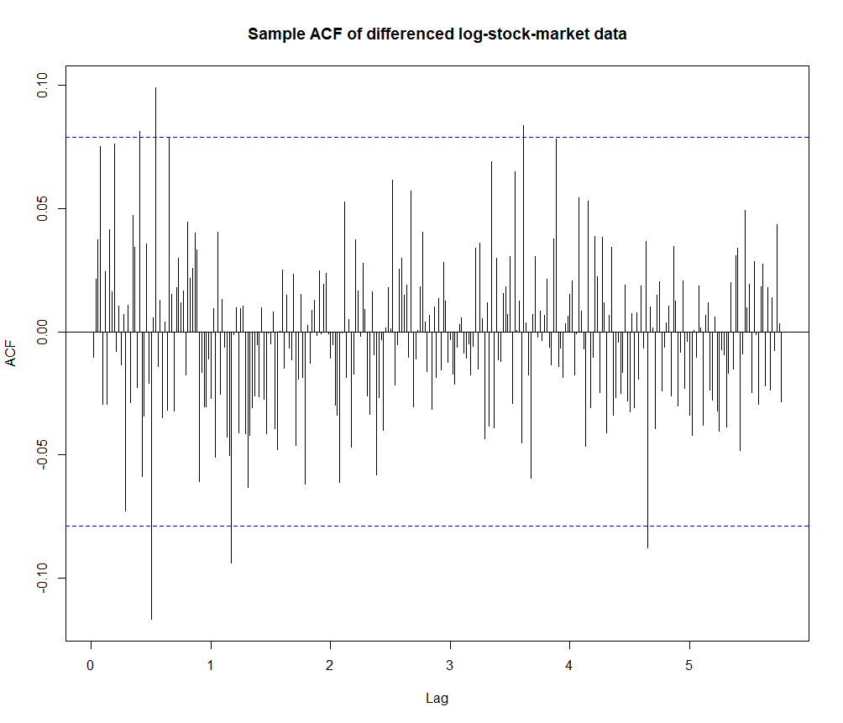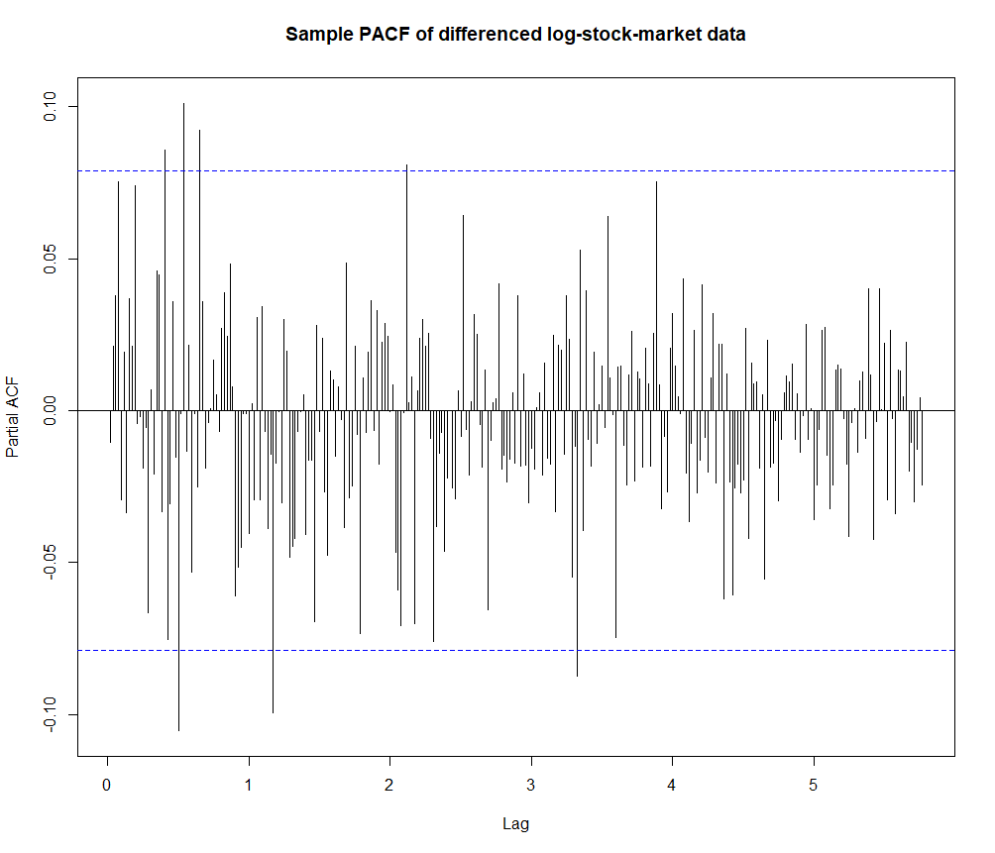

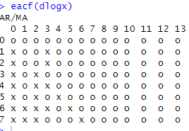

From the EACF we have considered four models and MA(3), ARMA(1,4), ARMA(2,4) and ARMA(3,3).

**Table 3.3.1**

|  |  |  |  |  |
| --- | --- | --- | --- | --- |
|  | MA(3) | ARMA(1,4) | ARMA(2,4) | ARMA(3,3) |
| AIC | -1870.05 | -1872.11 | -1867.65 | -1874.38 |

We compared all models in the below table(Table 3.3.2) and ARIMA(1,0,4) has the lowest rolling forecast error and has the third lowest AIC value. The ACF and PACF of the residual plots look clean and the p-value from the Box-Ljung test is 0.9523 which indicates that the residuals have white noise. The polynomial roots indicate that there is no redundancy since the roots are outside the root circle. By considering all these parameters we selected ARIMA(1,0,4) as our model.

**Figure 3.3.2 Residuals, ACF and PACF of ARIMA(1,0,4)**

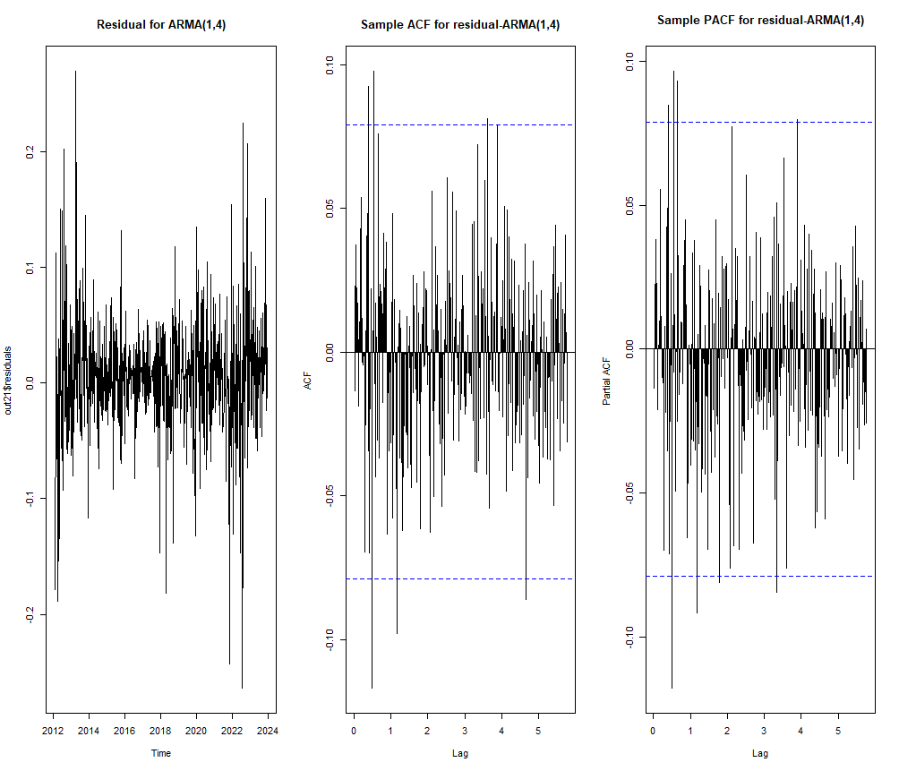

**Figure 3.3.3 Polynomial Roots of ARIMA(1,0,4)**

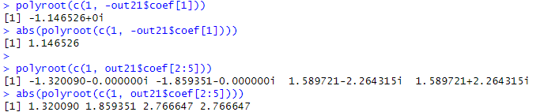

**Figure 3.3.4 Coefficients of ARIMA(1,0,4)**

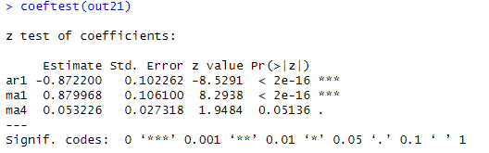

There is no drift issue since the intercept is not significant.

**Table 3.3.2 Models Comparison**

|  |  |  |  |  |
| --- | --- | --- | --- | --- |
|  | ARIMA(0,0,3) | **ARIMA(1,0,4)** | ARIMA(2,0,4) | ARIMA(3,0,3) |
| AIC | -1872.693 | **-1870.995** | -1872.679 | -1579.227 |
| ACF | clean | **clean** | clean | clean |
| PACF | clean | **clean** | clean | clean |
| Box-Ljung Test | 0.5162 | **0.9523** | 0.6911 | 0.9911 |
| Rolling Forecast | 0.4295681 | **0.4282883** | 0.4492347 | 0.4458569 |
| Redundancy | No | **No** | No | No |

**4. Prediction**

By using the model that we considered(ARIMA (1,0,4)) we can observe the prediction for the next 10 weeks where the predicted values start from the last observed data point and extend to the year 2024. The 95% prediction interval is calculated to provide a range of possible stock prices and indicate the uncertainty in the forecast. The historical data exhibits a generally upward trend, with some periods of volatility and fluctuations, and the predicted values seem to follow the overall upward trend, but with some deviations from the historical data. The stock price prediction model could be used by investors, analysts, or financial decision-makers to guide their investment strategies, though it's important to note that stock price forecasting is a complex task, and the accuracy of the model may be influenced by various factors not captured in the historical data**.**

**Table 4 Weekly Stock Price Prediction**

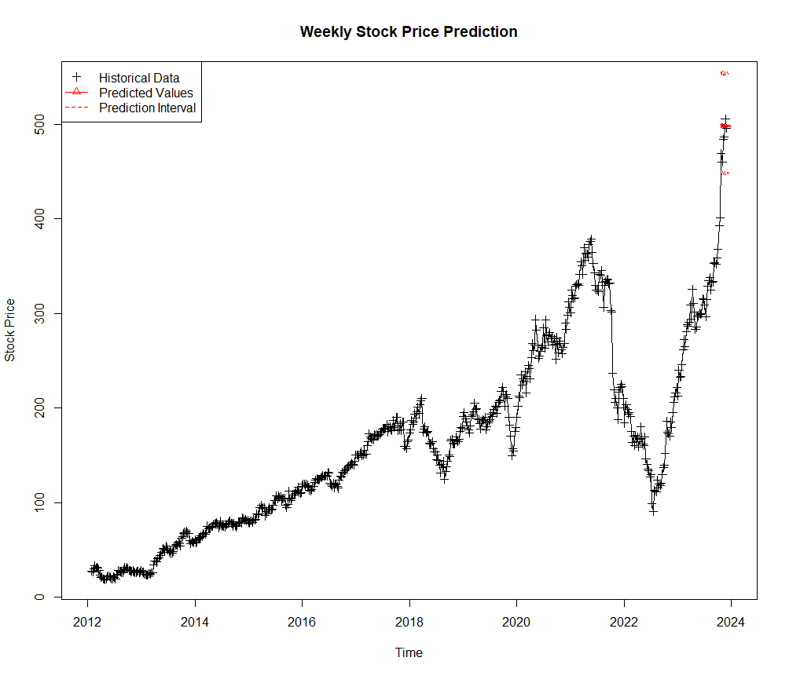

**5. Conclusion**

This time series analysis of Meta's stock price illustrates notable trends, seasonal patterns, and events that affected the company's stock price history from 2012 until 2024. While the company has had phenomenal growth, key drivers such as AI initiatives, renewable energy development, and increased free cash flow have been critical. However, competition, economic pressures, and heavy spending on metaverse projects have all had a substantial impact on stock price volatility. The prediction model we constructed implies that Meta's stock price will continue to rise, but future swings will be determined by how the firm handles these problems.

The analysis and projections presented in this report are useful for investors, financial analysts, and scholars who want to understand Meta's market behavior and forecast future stock moves.

**6. References**

* Meta Platforms Inc. (2024, December 10). *Meta Platforms (META) price prediction and forecast 2025-2030.* 247 Wall St.<https://247wallst.com/technology-3/2024/12/10/meta-platforms-meta-price-prediction-and-forecast-2025-2030/>
* MarketBeat. (n.d.). *Meta Platforms Inc. (META) stock chart.* Retrieved December 10, 2024, from<https://www.marketbeat.com/stocks/NASDAQ/META/chart/>
* Barchart. (n.d.). *Meta Platforms Inc. (META) price history.* Retrieved December 10, 2024, from<https://www.barchart.com/stocks/quotes/META/price-history/historical>
* TradingView. (n.d.). *Meta Platforms Inc. (META) stock symbol.* Retrieved December 10, 2024, from<https://www.tradingview.com/symbols/NASDAQ-META/>

**8. R-Code:**

library(tseries)

library(TSA)

library(lmtest)

md = read.csv("META.US_W1.csv")

head(md)

summary(md)

sum(is.na(md))

summary(md)

head(md)

str(md)

md$datetime <- as.POSIXct(md$datetime)

str(md)

#Time series plot

x = ts(md[, 5], start = c(2012,5), frequency = 52)

par(mfrow = c(1, 1))

plot(x, type='l', xlab='time', ylab='stock-market')

adf.test(x)

#Making data stationary

logx = log(x)

plot(logx, type='l', xlab='time', ylab='log(stock-market)')

adf.test(logx)

dlogx = diff(logx)

plot(dlogx, type='l', xlab='time', ylab='Diff(log(stock-market))')

adf.test(dlogx)

par(mfrow = c(1, 1))

acf(dlogx,main='Sample ACF of differenced log-stock-market data',lag = 300)

pacf(dlogx,main='Sample PACF of differenced log-stock-market data',lag = 300)

eacf(dlogx)

out = arima(dlogx, c(0, 0 , 3))

out

coeftest(out)

out2 = arima(dlogx , c(1, 0, 4))

out2

coeftest(out2)

out3 = arima(dlogx , c(2, 0, 4))

out3

coeftest(out3)

out4 = arima(dlogx , c(3, 0, 3))

out4

coeftest(out4)

out11 = arima(dlogx , c(0, 0, 3), include.mean = T, fixed = c( 0 , 0 , 0, NA))

out11

coeftest(out11)

out21 = arima(dlogx , c(1, 0, 4), include.mean = F, fixed = c(NA, NA , 0 , 0 , NA))

out21

coeftest(out21)

out31 = arima(dlogx , c(2, 0, 4), include.mean = T, fixed = c(NA, NA , NA , NA , 0, 0,NA))

out31

coeftest(out31)

out41 = arima(dlogx , c(3, 0, 3), include.mean = T, fixed = c(NA, NA , NA , NA , NA, NA, NA))

out41

coeftest(out41)

AIC(out11)

BIC(out11)

AIC(out21)

BIC(out21)

AIC(out31)

BIC(out31)

AIC(out41)

BIC(out41)

Box.test(out11$residuals, lag = 12, type = 'Ljung')

par(mfrow = c(1, 3))

plot(out11$residuals, main = 'Residual for MA(3)')

acf(out11$residuals, main='Sample ACF for residual-MA(3)',lag = 300)

pacf(out11$residuals, main='Sample PACF for residual-MA(3))',lag = 300)

Box.test(out21$residuals, lag = 12, type = 'Ljung')

par(mfrow = c(1, 3))

plot(out21$residuals, main = 'Residual for ARMA(1,4)')

acf(out21$residuals, main='Sample ACF for residual-ARMA(1,4)',lag = 300)

pacf(out21$residuals, main='Sample PACF for residual-ARMA(1,4)',lag = 300)

Box.test(out31$residuals, lag = 12, type = 'Ljung')

par(mfrow = c(1, 3))

plot(out31$residuals, main = 'Residual for ARMA(2,4)')

acf(out31$residuals, main='Sample ACF for residual- ARMA(2,4)',lag = 300)

pacf(out31$residuals, main='Sample PACF for residual- ARMA(2,4)',lag = 300)

Box.test(out41$residuals, lag = 12, type = 'Ljung')

plot(out41$residuals, main = 'Residual for ARMA(3,3)')

acf(out41$residuals, main='Sample ACF for residual-ARMA(3,3)',lag = 300)

pacf(out41$residuals, main='Sample PACF for residual-ARMA(3,3)',lag = 300)

polyroot(c(1, -out21$coef[1]))

abs(polyroot(c(1, -out21$coef[1])))

polyroot(c(1, out21$coef[2:5]))

abs(polyroot(c(1, out21$coef[2:5])))

polyroot(c(1, -out31$coef[1:2]))

abs(polyroot(c(1, -out31$coef[1:2])))

polyroot(c(1, out31$coef[3:6]))

abs(polyroot(c(1, out31$coef[3:6])))

polyroot(c(1, -out41$coef[1:3]))

abs(polyroot(c(1, -out41$coef[1:3])))

polyroot(c(1, out41$coef[4:6]))

abs(polyroot(c(1, out41$coef[4:6])))

source("rolling.forecast.R")

rolling.forecast(dlogx,5, length(dlogx)-100, c(0,0,3))

rolling.forecast(dlogx,5, length(dlogx)-100, c(1,0,4))

rolling.forecast(dlogx,5, length(dlogx)-100, c(2,0,4))

rolling.forecast(dlogx,5, length(dlogx)-100, c(3,0,3))

par(mfrow = c(1, 1))

# Load required libraries

library(forecast)

# Predict next 10 weeks

pp <- predict(out21, n.ahead = 10)

# Get the last log-transformed value of the time series

last_log_value <- as.numeric(tail(logx, 1))

# Compute cumulative sum of predictions and transform back to original scale

log_predictions <- cumsum(pp$pred) + last_log_value

pred <- ts(exp(log_predictions), start = c(2023.8, 1), frequency = 52)

# Calculate 95% prediction intervals (upper and lower bounds)

pred.upp <- ts(exp(log_predictions + 2 * pp$se), start = c(2023.8, 1), frequency = 52)

pred.low <- ts(exp(log_predictions - 2 * pp$se), start = c(2023.8, 1), frequency = 52)

nb <- 615

nn <- length(logx) # Total number of observations

tt <- (nn - nb ):nn # Indices of historical data to include

start_year <- 2012 # Adjust the starting year based on your data set

xxx <- ts(x[tt], start = c(start_year, 5), frequency = 52)

# Plot the historical data and predictions with 95% confidence intervals

xlim <- c(2012, 2024) # Set the x-axis limits

plot(xxx, type = 'o', pch = 3, xlim = xlim, ylim = rr,

xlab = 'Time', ylab = 'Stock Price',

main = 'Weekly Stock Price Prediction')

lines(pred, col = "red", lwd = 2)

lines(pred.upp, lty = 2, col = "red")

lines(pred.low, lty = 2, col = "red")

legend("topleft", legend = c("Historical Data", "Predicted Values", "Prediction Interval"),

col = c("black", "red", "red"), pch = c(3, 2, NA), lty = c(NA, 1, 2))